Ryan Elkin
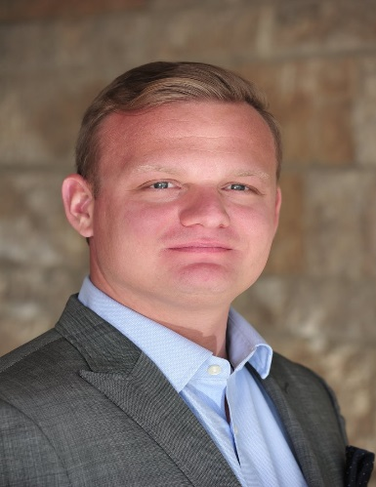

Ryan is from Lake Jackson, TX and grew up with his two younger brothers. After graduating from Texas, A&M University, he sought a commission as a US Naval Officer and was assigned to a counter-narcotics mission in South and Central America aboard the USS Robert G. Bradley (FFG49). Following his sea duty, Ryan served two years in Hawaii with the National Security Agency (NSA) followed by one year at Camp Dwyer In Helmand Province, Afghanistan.
After six active duty years in the Navy, Ryan pursued his full-time MBA from Rice University graduating in 2013. During his time at Rice, Ryan was a co-founder of the Veteran's in Business Association (VIBA) which now provides a full ride scholarship to one service member each year. Post-graduation, Ryan has served at numerous Big 4 Consulting firms focusing on Mergers and Acquisitions and was recently the Chief of Staff for the City of Houston's Finance Department. Ryan lives in Houston with his Floridian wife Melissa and has recently added a new furry member to the family.

